Excel Assignment - 9

1. What are the different margins options and do we adjust the margins of

the excel worksheet?

Ans: There are several options for adjusting the margins of an Excel worksheet, including:

* Top margin: The space between the top of the page and the top of the worksheet data.
* Bottom margin: The space between the bottom of the page and the bottom of the worksheet data.
* Left margin: The space between the left edge of the page and the left edge of the worksheet data.
* Right margin: The space between the right edge of the page and the right edge of the worksheet data.

To adjust the margins of an Excel worksheet, you can go to the Page Layout tab in the ribbon and click the Margins button. This will open a drop-down menu with several predefined margin options to choose from, such as Normal, Narrow, or Wide. You can also select Custom Margins to manually adjust the size of the margins to your desired measurements.

2. Set a background for your table created.

Ans: Select the table > Design tab > Table Styles > Select a Table Style > click on the drop down of the style > More colours > Select colour > Apply

3. What is freeze panes and why do we use freeze panes? Give

examples.

Ans: Freeze panes in Excel is a feature that allows you to lock certain rows or columns in place, so that they remain visible as you scroll through the rest of the worksheet. This can be useful when you have a large worksheet with a lot of data, and you want to keep the headings or key information visible as you scroll through the data.

For example, if you have a large table of data with columns for product names, prices, and quantities, you may want to freeze the top row that contains the column headings so that they remain visible as you scroll down the page to view the rest of the data.

4. What are the different features available within the Freeze Panes

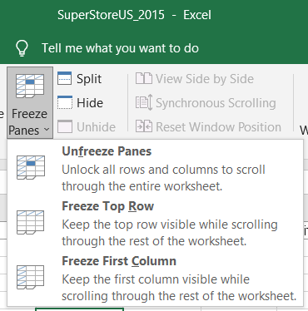command?

Ans:

5. Explain what the different sheet options present in excel are and what

they do?

Ans:

* New Sheet: This option allows you to add a new worksheet to the current workbook. Each new sheet added will have a default name such as Sheet1, Sheet2, etc.
* Rename Sheet: This option allows you to change the name of a selected worksheet. This can be useful for keeping the worksheets organized and easy to identify.
* Move or Copy Sheet: This option allows you to move or copy a selected worksheet within the current workbook or to a different workbook. This can be useful for organizing information or for creating backups of important worksheets.
* Delete Sheet: This option allows you to delete a selected worksheet from the current workbook. This can be useful for removing unnecessary or outdated worksheets.
* Select All Sheets: This option allows you to select all the worksheets in the current workbook at once. This can be useful for applying formatting or data changes to multiple worksheets at the same time.
* Group Sheets: This option allows you to group multiple worksheets together, so you can perform actions on them as a group. This can be useful for organizing worksheets and making it easier to navigate through them.
* Ungroup Sheets: This option allows you to ungroup the worksheets that were previously grouped together.
* Hide sheet: This option allows you to hide a selected sheet from the workbook. This can be useful when you want to keep the sheet for reference but don't want others to see it.
* Unhide sheet: This option allows you to unhide a sheet that was previously hidden.